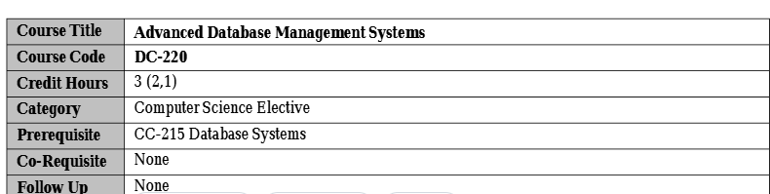
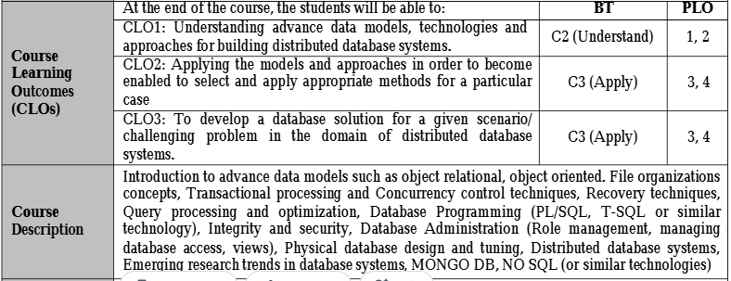
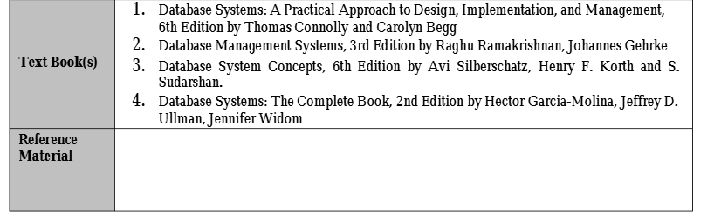
Lecturer: Adnan Majeed

